The Director,
Department of Skill Development,
Jammu and Kashmir.

No: KGP/Estt/2025-26/646 Dated:19-07-2025

Subject: Guidance Regarding Construction of Overhead Water Tank.
Reference:
1. Letter No.169-MLA-25, dated 19-07-2025, from the office of the Hon’ble MLA, Lal Chowk Constituency.
2. Letter No. WWD/Sgr/CC/1464-69, dated 09-06-2025, from the office of the Executive Engineer, Water Works Division, Srinagar.

Sir,
With reference to the above-cited subject and referenced letters, this office acknowledges the communication from the office of the Hon’ble MLA of Lal Chowk Constituency, indicating verbal consent from your end for the construction of an Overhead Tank (OHT) with a capacity of 1,00000 gallons at Kashmir Government Polytechnic College, Gogji Bagh, Srinagar. This initiative aims to address the persistent water supply needs of the Jawahar Nagar area under the AMRUT 2.0 Programme.
Further, this office has received correspondence from the Executive Engineer, Water Works Division Srinagar (copy enclosed), confirming their active engagement in ensuring the timely execution of the aforementioned 100,000-gallon Overhead Water Tank project.
In light of the above, this office respectfully seeks your formal guidance and approval to proceed with the necessary steps for the construction of the Overhead Water Tank at the earliest convenience.

Enclosures:
1. Letter from the office of the Hon’ble MLA, Lal Chowk Constituency.
2. Letter from the office of the Executive Engineer, Water Works Division, Srinagar

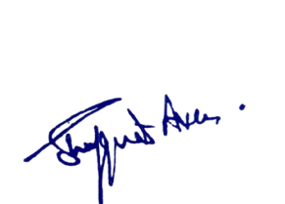
Yours Faithfully

Principal
Kashmir Government Polytechnic College
Srinagar

